Estimated student:
At the moment you complete the registration through the UMOVE application you will receive the credentials of the UJA ICT Account:
- User: ${user}
- Password: ${password}
In addition, with the same credentials you can access the email of Uja students (@red.ujaen.es) where you will receive all the information and notices.Therefore, it is very important to activate this GMAIL account and read the post office that you receive
You can enter the UJA email through:
- Intranet: https://www.ujaen.es/intranet. . . . GMAIL Mail Option.Using theUsername: ${user} and Password: ${password}
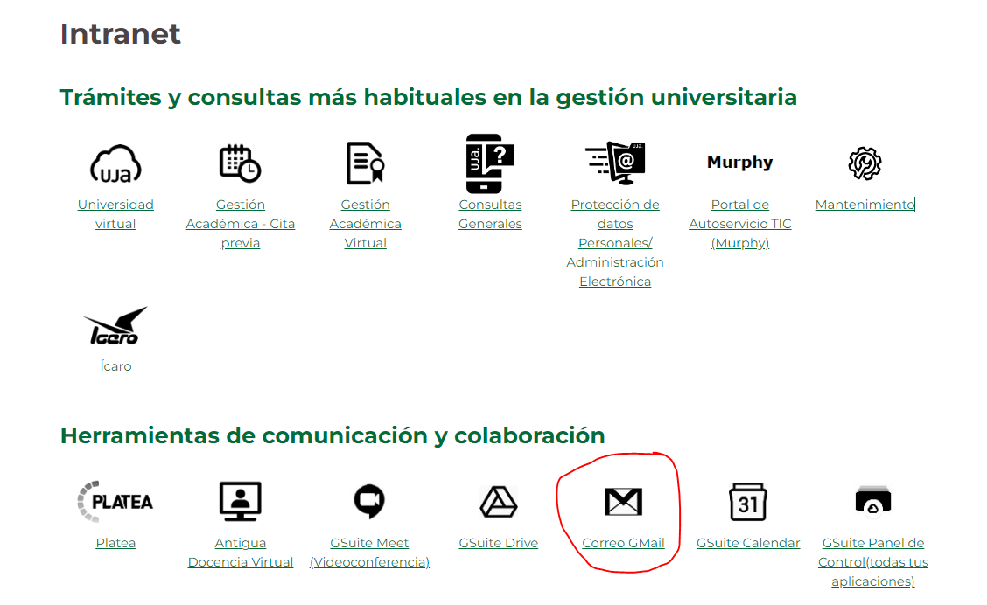
- via GOOGLE, UJA email is a GMAIL (GOOGLE) account. Using the following user ${user}@red.ujaen.es,and the same password from the previous section: ${password}
As soon as you have these credentials, all the procedures related to your mobility must be done from theCAMPUS VIRTUAL, the intranet of the University of Jaén. You can access it from the main page of the UJA website or directly at this address https://virtual.ujaen.es/srv/es/index.
Remember!YOU WILL RECEIVE ALL THE INFORMATION IN THAT EMAIL
Accede toCAMPUS VIRTUAL (https://uvirtual.ujaen.es/srv/es/index)
SEE PROCEDURES TO BE CARRIED OUT

